Experiment No. 2 Signal Operations and Transformations
(i)To perform amplitude scaling and time scaling of continuous-time and discrete-time signals and analyze their effects on signal characteristics.
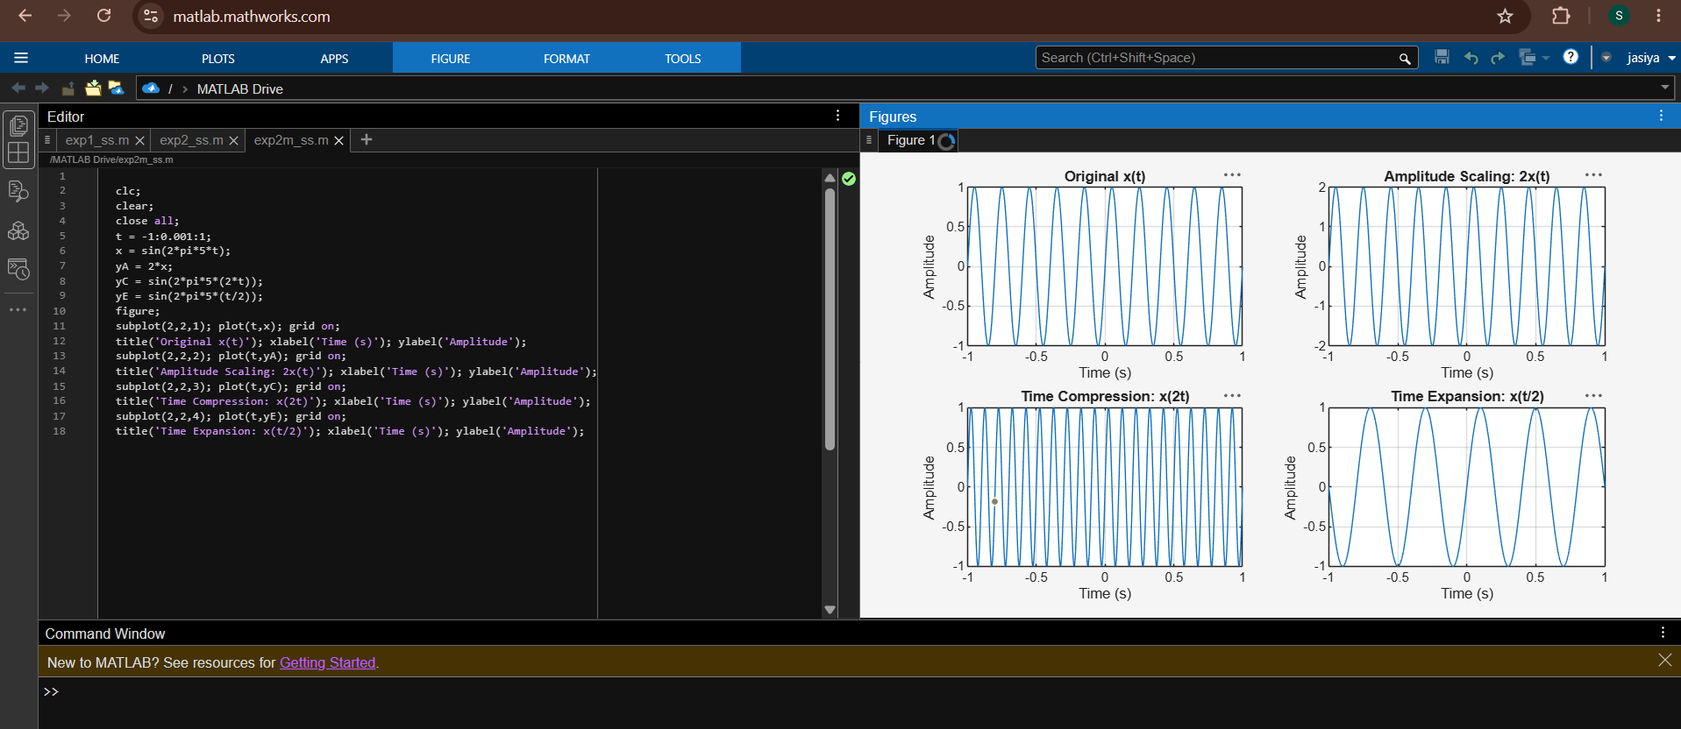
iii) To perform addition and multiplication of two discrete-time sequences and analyze the resulting signal characteristics
